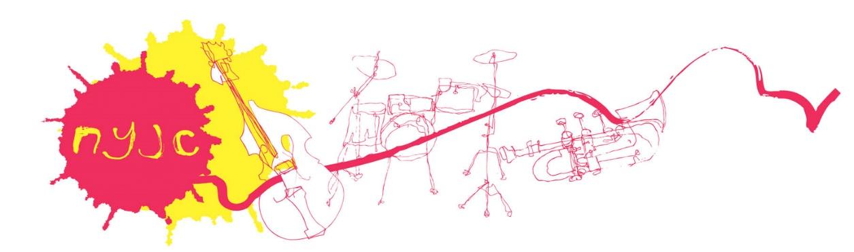

National Youth Jazz Collective
Chaperone Recruitment Pack, May 2022

National Youth Jazz Collective (NYJC) is currently seeking to appoint up to 6 new Chaperones to join their Summer School pastoral care team.

NYJC hold an annual residential Summer School, where young musicians create music alongside highly acclaimed professional musicians in a supportive and exciting setting.
There are 3 courses:
12th-14th August – Vocal Project
14th-20th August – Summer School
18th-21st August – Short Course
You may apply to chaperone for one course or all three.

NYJC celebrates diversity and inclusion. We welcome interest from all sectors and backgrounds and are keen to encourage applications from under-represented groups, particularly people from Black, Asian and ethnically diverse communities, but also a broad age-range and people living with disabilities.

This pack includes:
- Overview – National Youth Jazz Collective
- Role overview – Chaperone
- Terms of Employment
- Recruitment process
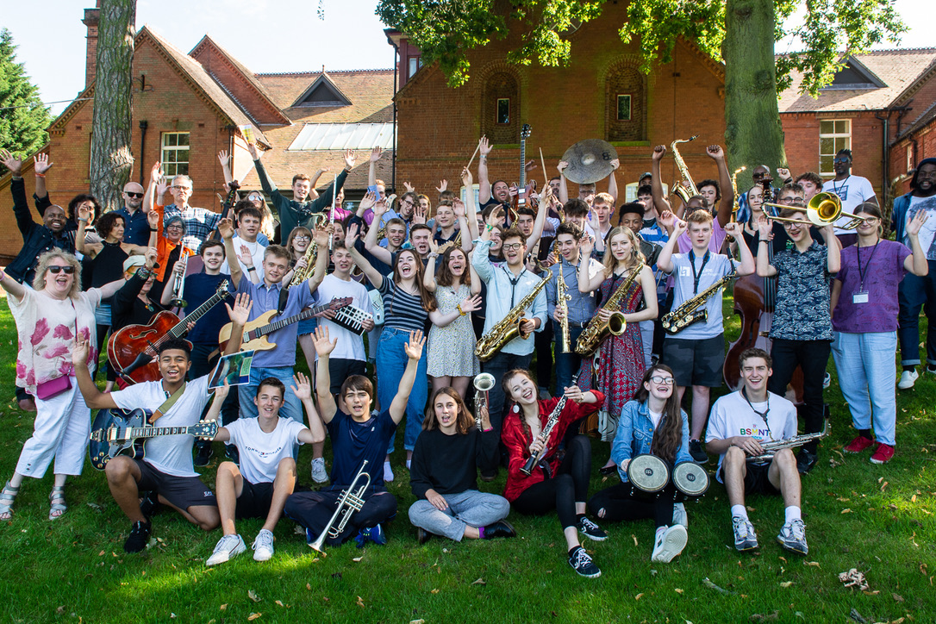

Overview – National Youth Jazz Collective

The National Youth Jazz Collective (NYJC) supports the creative and educational needs of the young jazz musician, focusing on small group composition and improvisation within a pathway of progression from beginners to young professionals.
Our mission is to:

- bring young jazz enthusiasts together to develop their skills, passion and experience as jazz players
- offer music education for 8–18-year-olds, helping them improvise, compose, arrange and lead their own bands
- provide teaching and learning materials for music teachers and schools to encourage and support young musicians to collectively improvise and compose.

NYJC was founded in 2007 and is led by Founding Artistic Director, multi award-winning composer, educator and record producer, Issie Barratt, cited in Radio 4’s 2018 power list as one of the 40 most influential women in the music industry. Issie is supported by an experienced Chief Operating Officer, Programme Manager and Finance Manager, 75 internationally renowned teaching artists (11% of whom are NYJC alumni) and a knowledgeable and skilled Board of Trustees. NYJC’s President is jazz luminary Dave Holland, and Vice Presidents include composer Sir Karl Jenkins, jazz pianist Julian Joseph OBE and Norma Winstone MBE. NYJC is a Charity, Company Limited by Guarantee and National Portfolio Organisation, receiving regular core funding from Arts Council England and the Department for Education, with additional project support from various Trusts and Foundations.

The National Youth Jazz Collective Summer School is the country’s pinnacle pre-degree jazz education opportunity for 14–18-year-olds. 90% of our summer school participants go on to study jazz at conservatoire before becoming leading lights on the jazz scene. Five of the ten semi-finalists and two of the five finalists of last year’s BBC Young Jazz Musician of the Year Award are NYJC Summer School graduates. Many have gone on to win Grammys, Parliamentary and JazzFM Jazz Awards and Paul Hamlyn and Ivor Novello Composer Awards – several of whom were in receipt of bursaries while with NYJC. All acknowledge NYJC as the significant experience that encouraged them to progress to higher education jazz studies and commit to becoming professional musicians.

2022 will mark NYJC’s 15th birthday. In our first fifteen years we have focused on piloting and developing a successful artistic programme, creating an award-winning pedagogy and effective progression route, supported by a range of online teaching and learning materials and a thriving alumni network that includes many of the leading figures in UK jazz.

Further information on NYJC is available here: National Youth Jazz Collective - NYJC

You can watch a 1-minute film about NYJC’s Summer School here: Summer School - National Youth Jazz Collective

You can get a flavour of what our Summer School participants achieve by watching the following: NYJC Summer School Concert 2021 – Malcolm Earle Smith and Mark Hodgson’s Combo

Role overview – Chaperone

Responsible in the first instance to the Head Chaperone.

As a Chaperone you will:
- Ensure the safety and security of all participants by following safeguarding procedures as appropriate.
- Promote a positive environment for participants to develop their creativity
- Support the Head Chaperone and other Chaperones with the day-to-day tasks involved in running a residential course.
- Supervise young musicians during scheduled breaks and monitor groups to ensure they are following instruction.
- Ensure the young musicians attend all mealtimes and activities.
- Supervise and support the young musicians in the residential setting, ensuring that you know the whereabouts of those in your care at all times.
- Feedback on a daily basis to the Head Chaperone and attend morning registration.
- Inform the Head Chaperone of any areas of concern, including accidents and incidents.
- Operate within NYJC guidelines regarding confidentiality.

We are looking for Chaperones who:
- Have experience in working with young people, including safeguarding.
- Have a current enhanced DBS certificate, preferably on the update service.
- Are aged over 21 – the participants range from ages 14-18
- Have great communication skills.
- Are sensitive to the needs of young people in a residential setting, including those with additional needs.
- Can maintain a good rapport with young people.
- Are able to maintain discipline in a residential setting.
- Can work effectively as part of a team.
Terms of Employment
This is a freelance, pastoral role, so there is no requirement for an interest or aptitude in jazz.
Fee: £81 per day
Accommodation and meals are provided
Dates:
12th-14th August
14th-20th August
18th-21st August
Please indicate whether you applying for one course or all three.

Hours: Pastoral responsibility lasts throughout the course. However, suitable breaks will be timetabled to ensure on duty and off duty periods. In case of emergency, all chaperones to have access to a mobile phone

Recruitment process

Candidates are asked to submit a current CV and a one-page letter of application, outlining their experience and suitability for the role to Sonia Mellor, Head Chaperone, sonia@nyjc.co.uk by midnight, Sunday 5th June 2022.

Interviews will be held on the afternoons of Tuesday 7th or Wednesday 8th June 2022 online through Zoom.

If you would like to have an informal conversation about the opportunity or have any questions, please contact Sonia Mellor on sonia@nyjc.co.uk,

Please complete an Equal Opportunities Monitoring Form with your EOI. The form is anonymised and can be found here: NYJC Equal Opportunities Form (jotform.com)

